- 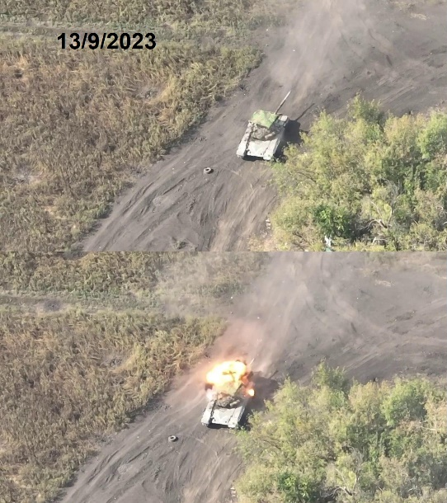  Ukrainian kamikaze drone impacting against the turret of a Russian T-72B3  – image from Oryx |  | - Policy Brief – National Defense

Ukrainian Drones vs. Russian Armor

Executive Summary
The Ukrainian military has increasingly been using UAV’s as an alternative to aircraft supported ISR, close air support, and increasingly anti-tank missiles in the absence of equipment and air superiority. The use of these drones as an anti-armor platform marks a significant change in the conflict, and U.S. policy makers, in the Department of Defense should take note on how to duplicate, refine, and defend against similar tactic in the development of future U.S. armored vehicles and doctrine.
“And then of course there’s the kamikaze tactic, which is to just strap an explosive to a drone and run it right into a target, like a tank” ~ Johnny Harris, 2023  - Author  James O’Neil  Department of International Security  University of Arizona  POL-578  Prof. Andrew Grogan, PHD |  | Context  Since the start of the Summer Offensive (June to Nov 2023), more than 353 Russian Tanks, 519 IFVs, and 166 Self-Propelled Artillery have been destroyed. Over this period, Ukraine claims drone attacks constituted up to 50% of Russian armor losses (only <1.7% of these can be confirmed as of the time of writing) as Ukrainian drone operators refine their tools, techniques, and procedures (TTPs). These drone attacks are used as an alternative when more conventional infantry anti-armor weapons or assets, such as Javelin missiles or close air support, are not accessible. More critically, the cost of these improvised drone platforms is far cheaper, tactically flexible, and with a reduced threat signature compared to existing NATO or Russian platforms.  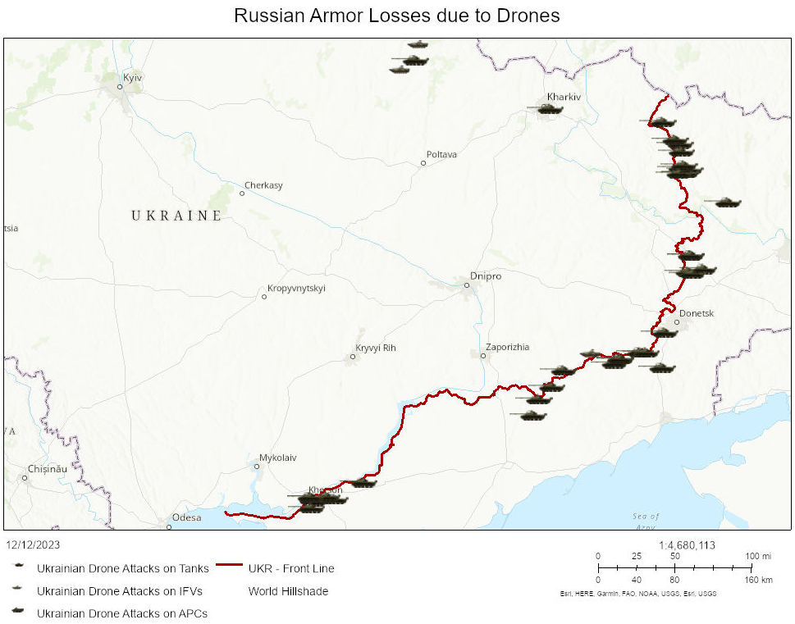

Analysis
Ukrainian drone attacks against Russian armor fall into one of two attack vectors. The first is the use of drones configured for anti-personnel use, having been customized to drop hand grenades, mortar rounds, or other improvised/repurposed bomblets onto an open compartment hatch or different vulnerable location of a tank or armored vehicle while they are stationary. These attacks drop payloads with surprising precision, between 10 to 100 feet above the target. These attacks are more in the vein of targets of opportunity, catching armor crew unaware and exposed.
The alternative is generally a kamikaze/suicide drone explicitly designed to target armored vehicles. These slightly larger drones carry repurposed anti-armor warheads from an RPG-7, S-5, or other available/improvised high-explosive anti-tank (HEAT) munition. Unlike conventional anti-tank infantry platforms, these can potentially choose their angle of attack, allowing the operator to attack weak side/rear/top armor at their discretion and the ability to potentially make multiple attack runs or recover the drone if a target is not present, allowing such drones to be deployed both as an ISR platform with the ability to act as a guided missile if targets present themselves, a utility previously only available on larger UAV platforms armed with Anti-Tank Guided Missiles (ATGM), such as the U.S. MQ-9 Reaper or the Turkish Bayraktar TB2, both of which have much larger radar signatures and cannot be deployed safely without suppression of enemy anti-air systems.
These drones, having the ability to act as both an ISR platform, also give the advantage of allowing crews to attack armored vehicles in defilade, behind cover, or outside the direct line of sight, which is again an advantage over conventional line of sight anti-tank weapons, that Infantry traditionally have access to. Additionally, the drones can be reused/recovered, but are also cheap and easily replaced if they are damaged/destroyed in combat, with Anti-tank drones costing less than $1000 USD to make and arm, meaning Ukraine can furnish 90+ kamikaze drones for the cost of each Javelin missile.
Russian anti-drone efforts have been crude and seemingly ineffective or easily circumvented. Russian Main Supply Routes (MSRs) now follow main roads, where camo netting is hung between light posts in hopes of catching Ukrainian attack drones, to middling success. Russian ECM jamming has spawned the generation of ‘repeater’ drones to daisy-chain signals to penetrate jamming bubbles and enable attack drones to reach their targets. Further, drone operators have proven proficient at maneuvering around contemporary improvised vehicle armor meant to help mitigate the threat of other modern anti-tank weapons.

Considerations & Blind-spots
Ukraine's claims on the effectiveness of their attack drones far exceed what is publicly verifiable at this time, using OSINT/GEOINT collection methods. The efficacy of these platforms is likely higher than the 1.7% that can currently be verified but lower than the 50% claimed by Ukrainian General Staff as of Early September. Ukrainian general staff claims seem to also claim armor kills consistently in the realm of 100 units greater than is publicly verifiable. Drone attacks that are reported on seem to also be on the edges of the 3-pronged summer offensive, or along the static defenses, perhaps due to the lower risk to journalists to report in these areas or of less operational security concerns for the Ukrainian army to report on.
As demonstrated in Ukraine, these drones differ drastically in scale and capabilities from those implemented in U.S. doctrine and lack standardized parts, design, and defined doctrine standardization. As standardization of both equipment and techniques continues to be refined and the novelty of this threat vector ceases, a better understanding of the effectiveness of this style of drone combat will be more apparent. The ubiquity and ease of production of such platforms should be concerning as an asymmetric warfare platform, that could be utilized by terrorists and rogue states such as North Korea and Iran as a means of combating their conventionally stronger adversaries in the near to short term.

Recommendations
While Russian/Soviet and NATO armor design doctrines differ significantly, the threat of drones equipped with HEAT or similar penetration rounds must be considered, especially for the top armor. Doctrine surrounding keeping the crew compartments closed whenever possible to mitigate the threat of anti-personnel armed drones should be considered.
The U.S. and NATO should explore Hard and Soft Kill anti-drone defenses, potentially in the form of lasers to burn out drone optics or dazzle operators, jam operational radio frequencies, or destroy hostile drones via kinetic weapons upon approach via a point defense system akin to the Israeli Trophy point defense system.
U.S. Infantry doctrine should explore and implement similar drone capabilities to augment and expand anti-armor capabilities while enabling further situational awareness via drone-enabled ISR at the squad, platoon, and company level.

